GuardianSync: Real time tracking with face recognition and attendance monitoring system

Ms. Richa Saxena 1  
Department of Computer Science and Engineering  
Moradabad Institute of TechnologyMoradabad, India  
e-mail: richasaxena2006@gmail.com

Ankit Saini 4  
Department of Computer Science and Engineering  
Moradabad Institute of TechnologyMoradabad, India  
e-mail: ankitsaini28052003@gmail.com

Abhishek Rajpoot 2  
Department of Computer Science and Engineering  
Moradabad Institute of TechnologyMoradabad, India  
e-mail: imexclusiveabhi@gmail.com

Aleem Malik 5  
Department of Computer Science and Engineering   
Moradabad Institute of Technology  
Moradabad, India  
e-mail: aleemmalik7786@gmail.com

Ajay Kumar 3  
Department of Computer Science and Engineering  
Moradabad Institute of TechnologyMoradabad, India  
e-mail: ajkumar96214@gamil.com

***Abstract*— This paper presents the design and implementation of GuardianSync, a real-time child safety monitoring system that integrates live face recognition, GPS-based location tracking, and automated SMS alerts to ensure secure school commutes. The mobile application, developed in React Native, allows drivers to register and authenticate using role-based access while providing real-time location updates to the backend. The web portal, developed using the MERN stack (MongoDB, Express.js, React.js, Node.js), enables parents and admins to track attendance statuses such as “Picked Up,” “Dropped,” and “Not Coming Today.” Vite is used to create a responsive, high-performance portal for visualizing live location on a map. Upon successful face verification via the camera and stored database image, the system sends an SMS notification to the parent to confirm pickup or drop-off. The backend architecture is optimized for scalability and security, ensuring that sensitive data such as location and identity are protected through encryption techniques. In addition to real-time monitoring, the system maintains historical logs of attendance and travel history for administrative review and audit purposes. The paper outlines the practical implementation of this system, detailing its architecture, major software modules, database design, and the communication workflows between devices, all aimed at addressing real-world challenges in child transportation safety with efficiency and reliability.**

**Keywords— Real-time tracking, GuardianSync, child safety, face recognition, MERN stack, React Native, GPS monitoring, mail alerts.**

# Introduction

Child security ranks high among parents and institutions as one of the most critical issues. Travel to and from school to home presents numerous challenges, especially in accurately determining who collects or takes the children home. Numerous parents want to know who takes the children to and from school and misidentification at pickup time [1]. Some of the issues that necessitate the need to create systems to not only trace the location of the child but also authenticate the person picking them from school in real time—a requirement for increased security and peace of mind [2].

This system combines real-time attendance with identification verification and location tracking into one platform to assist in addressing the ever-rising concern. Merging the essential functionalities into one, the proposed system presents an end-to-end solution to the challenges of securing children [3]. The system employs the latest in web and mobile technologies, allowing schools and parents to see who the children attend with and where they move about the school throughout the day [4]. This allows only the recognized individuals to pick up or drop off the children, reducing the likelihood of errors and wrong pickups.

The system, equipped with live face recognition, verifies who the person picking the children up or dropping the children off is before any action such as recording the attendance of the child or changing the status of the child [5]. This adds high security, whereby the verification relies on pre-registered images of the children. The system automatically sends real-time email updates to parents to report any status updates to the child, whether pickup, drop-off, or absent status.

With the incorporation of GPS location tracking, it allows for ongoing tracking of the exact location of a child, thereby allowing parents and school administrators to observe the child's movements in real time. This degree of accuracy allows parents to be aware of the exact location of the child in order to allay fears about the safety of the child in transit [6].

Furthermore, the user-friendly interface of the system makes the registration and updating of status very accessible to parents, guardians, and schools. The system boasts of its live face recognition capability, offering a very secure mode of identification verification. This means that before any action such as a pickup, drop off, or a mark of absence, the system accurately identifies the child from a pre-registered image. This minimizes the possibility of identification errors or pick-up by unauthorized individuals, hence drastically increasing security.

The system also increases its utilization through automatic delivery of email updates to parents in the case of every action such as a pickup, drop off, or mark of absence. This provides clear communication between parents [7] and the school, allowing parents to receive updates of the status of the child at all times despite being away from the school. In the end, the combination of GPS tracking, face recognition, and email alerting presents a complete platform for children's safety [8], allows parents to have peace of mind, and serves the operational requirements of schools.

# Literature Review

Current child safety solutions primarily focus on GPS-enabled location tracking and RFID-based attendance monitoring. GPS technology, [9] which relies on satellite signals to pinpoint and relay a device’s geographical coordinates, has become widely adopted by caregivers seeking real-time updates on a child’s movements [10]. Similarly, RFID employs radio-frequency tags—often embedded in wearables like bracelets or ID cards—to monitor proximity. While these tools help oversee children’s commutes to schools or activities, both face limitations in authenticating identity. For instance, GPS confirms a device’s location but cannot verify if the child associated with that device is correctly identified during pickup or drop-off, leaving room for potential mismatches or security breaches.

Integrating facial recognition addresses these gaps by adding biometric verification, elevating safety standards beyond mere location tracking [11]. Unlike GPS or RFID, which only signal presence or position, facial recognition ensures the individual’s identity matches authorized records, minimizing risks of unauthorized access. Studies indicate that real-time biometric systems enhance security protocols by linking access privileges to verified identities. In childcare scenarios, this means only pre-approved guardians can retrieve a child, drastically lowering abduction risks or unintended handovers. Additionally, biometric authentication fosters trust between families and institutions by reinforcing accountability,[12] thereby cultivating a safer environment for children’s routines. offering caregivers greater reassurance while streamlining institutional safety practices.

Contemporary GPS technologies, such as those powering delivery rider tracking apps, excel at providing real-time location data for vehicles and passengers are very efficient for real time location [13] provision of both vehicles and their occupants. But integrating biometric verification systems into these systems is not an easy task. The supporting technology for GPS tracking is quite a mature one; however, its combination with real-time facial recognition systems [14] requires complex algorithms and great processing power. Due to the need for fast image capture and processing, several limitations are experienced especially in situations where images have to be captured in a progressive manner, such as during school pick-up when different light intensities and numerous children exist. In addition, in order for a face recognition system to be effective and accurate, a significant amount of quality data has to be acquired for the purposes of training the algorithms used in machine learning. If such data is to be useful in enhancing the model training, it has to be highly diverse owing to factors such as age differences, various faces and the differing features of individuals, else there will be many false positives during identity verification.

In the last few years, there has been a renaissance in the design of systems that are hybrid in nature such as, combining GPS tracking with RFID attendance systems and biometric screening techniques [15]. Such systems are an attempt to develop a safety net which goes further than just tracking children’s movements in real time but also goes to the extent of validating their identities prior to any pick-ups and drop offs [16]. Several investigations have been done in this field on integration of these technologies regarding their structures and algorithms but addressing user experience and system performance as well. For example, interface designs should allow for children’s pictures to be quickly and easily registered, with the ability to use face recognition technology at the same time without making it obvious during pick-up periods. Moreover, the advent of cloud computing and edge processing offers new possibilities in real-time processing which were not possible before thereby enabling faster and more efficient operations in dynamic environments [17].

In conclusion, the persistent exploration of the combination of global positioning systems, radio frequency identification devices, and face recognition technology is a great advancement in the systems meant for the protection of children. These hybrid systems overcome the drawbacks of previous systems as effective as each technology is, they can be useful to parents and schools more efficiently. The next generation of child protection systems will be characterized by location monitoring and biometric identification working hand in hand, thereby enhancing security [18] and enabling parents, guardians, and schools to work together. A continued enhancement of these systems and their relative features as these technologies grow over the years, I believe that attention on user needs and system effectiveness will save our children whenever they step out of home and are being transported.

# Methodology

* **Module 1: User Authentication (Login/Signup)**

Security aspects like user authentication constitute the very backbone of any system that has to be secure and reliable—especially in applications designed to ensure the safety of children due to the sensitivity of the data and control over operations.

In the GuardianSync system, user authentication is implemented distinctly for two roles: **Wheels** and **Toes**. This role-specific division enables unique functional capabilities while maintaining robust protection mechanisms and access controls.

* **Wheel** accounts are assigned to drivers, responsible for safely transporting children.
* **Toes** accounts are meant for parents, allowing them to track the vehicle’s location and monitor their child’s safety.

The framework utilizes **JWT (JSON Web Tokens)** for user verification and session management. JWT provides a secure, stateless, and scalable way to manage user sessions—removing the server-side load of session storage.

**Driver Accounts** are used by drivers to log in and manage the transportation process. After successful login, drivers can:

* View the list of children assigned to their route
* Update each child's pickup/drop-off status

A built-in **GPS system** allows for real-time monitoring of the driver's route, pushing live updates to both parents and school administrators.

**Parent Accounts** provide guardians with key tools to:

* Track the location of the vehicle
* Monitor the real-time status of their child
* Receive timely email notifications regarding events such as pickup or drop-off

The system’s use of **strong authentication methods** for differentiating between driver and parent accounts helps to prevent unauthorized access and significantly reduces potential risks within the system.

* **Module 2: Child Registration**

Registration of the child is a key system operation primarily handled by the **administrator** to ensure all necessary details are accurately captured and securely stored. During this process, the admin inputs comprehensive information such as:

* Child’s name
* Class, roll number, and section
* Parent details including name, contact number, and address

This data is securely stored in the **backend database**, which acts as the foundation for other core system features like real-time GPS tracking, facial recognition, attendance status updates, and more. The registration workflow is intentionally designed to be **simple and intuitive**, allowing administrators to register students efficiently—either at the beginning of the academic year or anytime thereafter with minimal effort.

### **Photo Registration for Face Recognition**

One of the most essential steps in the registration process is **Photo Registration**. This involves capturing a live photo of the child and saving it in the system. This image becomes a key component in the **facial recognition** module, which is triggered during pickup routines to ensure that only authorized children are matched with designated drivers.

When a child is registered in **GuardianSync**, their photo is linked to their profile, providing a secure method of real-time identity verification. This mechanism significantly helps in preventing unauthorized or mistaken pickups. However, the **effectiveness of face identification** heavily depends on the **clarity and quality** of the registered photo—making this step both sensitive and critical.

* **Module 3: Real-Time Location Tracking**

### **Real-Time Vehicle Tracking**

Continuous tracking of the vehicle's location is a **core functionality** in the GuardianSync system, giving both parents and administrators the ability to monitor the vehicle's movements at all times. The system integrates **GPS technology** within the mobile application, which continuously uploads the driver's live location to the backend in real time.

This location data is securely stored in the **backend database** and visualized through a **moving map** on the **parent's web portal**. The mobile app plays a crucial role in consistently pushing location data, ensuring that the system always reflects the current position of the vehicle. This level of real-time tracking is especially valuable for parents who want to stay informed about their child's travel status and the vehicle’s route progress.

### **Map View Interface Built with Vite**

The parent web portal is built using **Vite**, a modern and lightning-fast web development framework that enables the creation of highly performant and responsive interfaces. One of the main features of the portal is the **Map View**—a dedicated section that shows the **live location of the vehicle**, similar to delivery tracking in apps like Zomato.

With this view, parents can:

* Monitor the vehicle's current location in real-time
* Get an estimate of when the vehicle will arrive
* Feel assured that their child is safe and accounted for during commutes

The integration of **GPS tracking with real-time map visualization** not only enhances communication but also boosts **parental confidence in the safety and reliability** of their child’s daily transit.

* **Module 4: Facial Recognition for Pickups**

To enhance child safety during pickups, **GuardianSync** incorporates real-time **facial recognition** technology in its mobile application. The driver app activates the device’s camera to capture a live photo of the child. This image is then compared against the child’s **pre-registered image** stored in the backend during registration.

**Pickup can only proceed if the match is successful**, ensuring that only the right child is picked up by the designated driver. This significantly reduces the chances of unauthorized or mistaken pickups.

**Equations**

**Feature Extraction Using Principal Component Analysis (PCA)**

Principal Component Analysis was implemented to reduce the dimensions of image data while retaining significant features. This procedure projects data into a new space in such a manner that the variance is maximized, hence retaining most of the informative aspects in reduced dimensions. Thus, PCA outdoes LDA on the task of capturing the most meaningful variance in data.

**Steps of PCA for Dimensionality Reduction**

Given MM training images x1, x2 ,.,xMx1​ , x2​,.,xM​, each represented as a vector of size NN:

Calculate Sample Mean:

The average face ΨΨ is computed by summing each of the vectorized versions of the training images and dividing by the total number of images MM:

Ψ=1M∑i=1Mxi …. (1)

ψ=M1​i=1∑M​xi​ …. (1)

**Normalize Data:**

Each image vector xixi​ is mean-centred by subtracting the mean vector ΨΨ:

φi=xi−ψ …. (2)

Φi​=xi​−Ψ …. (2)

**Calculate the Covariance Matrix:**

Therefore, the covariance matrix ΣXΣX​ of the cantered dataset is pre-computated so that it reflects the spread of data points in each dimension:

ΣX=1M∑i=1MΦiΦiT …. (3)

ΣX​=M1​i=1∑M​Φi​ΦiT​ …. (3)

**Calculate Eigenvalues and Eigenvectors:**

Then, ΣXΣX​'s eigenvalues and their vectors are calculated, and the top KK eigenvectors corresponding to the largest KK eigenvalues are chosen for optimum base vectors. Eigenvectors here represent principal components. Their corresponding eigenvalues will show how much variance each component captures.

To avoid computational complexity, we will employ ATAATA which will be an M×MM×M matrix instead of doing ΣX=AATΣX​=AAT directly. Let μiμi​ and vivi​ be the eigenvalues and eigenvectors of ATAATA. Multiplying both sides by AA gives us the eigenvectors for AATAAT which in turn give us the NN-dimensional eigenvectors.

**Project Data to Lower-Dimensional Space:**

Using the KK largest eigenvectors, each training image xx is represented in a reduced dimensional eigenspace which reduces data complexity significantly.

**Eigenface Application**

Each of these images was vectorised by stacking the rows, yielding a vector of length N=N1×N2N=N1​×N2​. If one had computed the covariance matrix ΣXΣX​ directly from that representation, then one would have obtained an N×NN×N matrix, which is computationally too expensive. Using ATAATA one reduces computation to a mere M×MM×M matrix:

ATA …. (4)

ATA …. (4)

These vectors when multiplied by AA give the eigenfaces which are the variations of the training images. Each eigenvector is normalized and mapped to the range [0, 255] to view it and saved as .pgm files.

**Experimental Configuration**

**Calculation for Average Face:**

As in Equation, the average face was computed by summing each vectorized image and dividing by MM. This resulting vector was then saved as a.pgm file.

**Eigenface Generation:** Following that, the eigenfaces were arranged in descending explained variance order. The highest eigenvalues correspond to the highest variance eigenfaces, representing key facial features, whereas the lower-variance ones represent less important details.

**Testing and Classification**

**Mean subtraction**

For every test image ΓΓ, the average face ΨΨ was subtracted from the training set to center the test data:

Φ=Γ−Ψ …. (5)

Φ=Γ−Ψ …. (5)

**Projection into Eigenspace:** By using the following transformation, the unknown test image ΓΓ was projected into the eigenspace:

Ω=(y1,y2,.,yK) …. (6)

Ω=(y1​,y2​,.,yK​) …. (6)

**Similarity Measure-Manhalanobis Distance:** To classify the test image, the Mahalanobis Distance-distance in the face space-between ΩΩ of the test image and every ΩiΩi​ in the training set was computed. The training image for which this distance to ΩΩ was the least was taken as the best match. It finds the best similar image using a distance metric; also called "distance in face space" or DIFS. Threshold for eigenvalues: To retain 80% of the data variance, we computed the cumulative sum of eigenvalues and determined K such that it explained the required variance. We plotted CMC curves by iterating N from 1 to 50 and recorded TP, FP, TN, and FN values at various thresholds for further analysis.

**Visualized Results**

The ROC and CMC curves visualize the model performance across different resolutions. While high-resolution data enjoys better classification accuracy with higher true positive rates and better match probabilities at lower ranks, low-resolution data may exhibit poor performance: its ROC curve would be closer to the random classifier line, with a less steep CMC curve, which indicates reduced discriminative power.

**High Resolution**

* **CMC Curve:** Shows the probability of finding the correct match within the top "Rank" matches (Fig 1).
* **Rank (x-axis):** Number of attempts allowed to find the correct match. Higher ranks increase the chance of correct identification.
* **Performance (y-axis):** Cumulative probability of correct identification, indicating recognition accuracy.

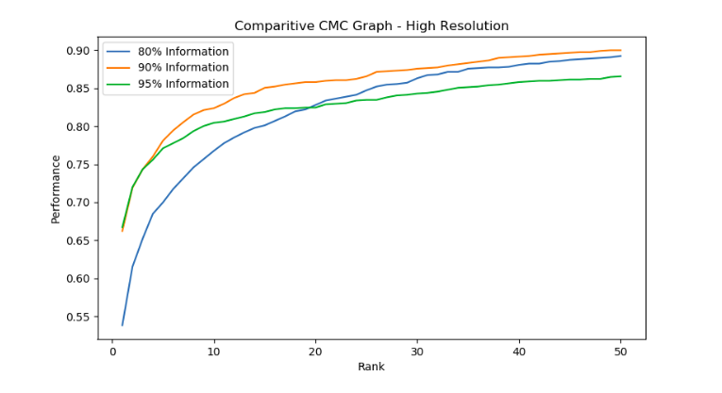

Fig 1. Comparative CMC Graph-High Resolution

* **80% Information (Blue Line)**: Lower dimensionality; reduced performance, especially at lower ranks.
* **90% Information (Orange Line)**: More features retained; improved accuracy over 80%.
* **95% Information (Green Line)**: High-dimensional representation, but with diminishing returns in performance improvement.

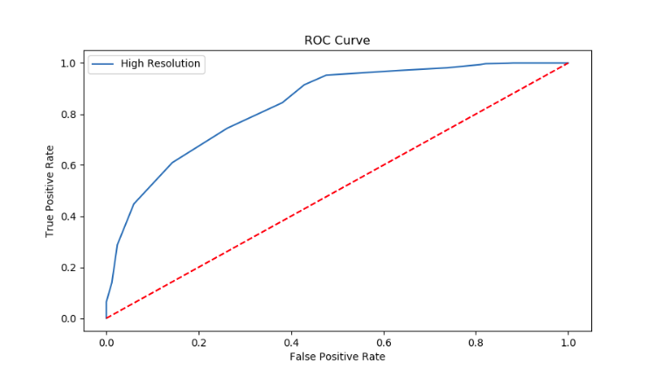

Fig 2. ROC Curve-High Resolution

* **Curve Shape**: The ROC curve starts from (0,0), quickly rises to a high **True Positive Rate** with a low **False Positive Rate** and then gradually approaches the top-right corner. This indicates a good balance between true positives and false positives (Fig 2).
* **Diagonal Line** (Red): Represents random guessing. The ROC curve being above this line indicates that the model performs significantly better than random classification.
* **Classifier Performance**: Since the curve approaches the top-left corner, the model shows high discrimination ability, with a low rate of false positives for high true positives.
* **Interpretation**: The ROC curve suggests that the high-resolution model is effective at distinguishing between classes, with a strong tendency toward accurate classification across different thresholds.

**Low Resolution**

The Cumulative Match Characteristic (CMC) graph in low-resolution conditions, as shown, compares the model's performance across different levels of available information—80%, 90%, and 95%. CMC curves demonstrate the likelihood that a correct match appears within the top *n* ranks, making them a useful tool for evaluating rank-based retrieval and classification systems (Fig 3).

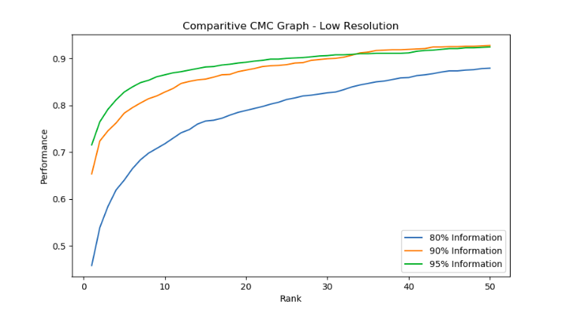

Fig 3.Comparative CMC Graph-Low Resolution

* Higher information levels (90% and 95%) yield better performance across ranks. As seen, the 95% information curve consistently achieves the highest match probabilities, followed by the 90% curve, with the 80% information curve showing the lowest performance.
* At lower ranks (e.g., Rank 1–10), the CMC curve for 95% information rises sharply, indicating that with more information, the model is more likely to retrieve the correct match within the top ranks.

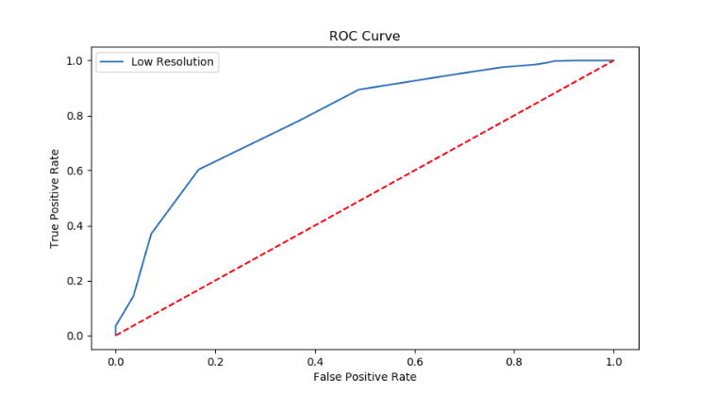

Fig 4. ROC Curve- Low Resolution

* **ROC Curve Shape:** It rises steeply first, which means that in some thresholds, the model can easily attain a high True Positive Rate with low FPR; then if the FPR grows, the growth of the TPR becomes gradual. Therefore, it depicts that at higher levels of threshold, decay can be observed (Fig 4).
* **Performance of random classifier:** The red dashed line is a random classifier where the AUC is 0.5. The TPR is equated to FPR across the thresholds. Given that your curve is well above this, the model is doing better than random; thus, it does have predictive powers.
* **AUC Interpretation:** Though I cannot calculate the AUC from this picture, the shape of the curve suggests a moderate value of AUC. That means, standard performance of the model in distinguishing between two classes, though not very strong.

The **Facial Match Verification** process is designed to be both accurate and efficient. The system uses advanced facial recognition algorithms that compare various facial landmarks to ensure that the identity of the child is accurately confirmed. In cases where the match is successful, the child’s status is updated in the system as “Picked Up.”

1. **Module 5: Pickup and Drop-Off Status Update**

Following the validation of facial recognition, the motorist can select one of the three options available that are accessible upon successful updating of the status of the child. The status options comprise of Picked Up, Dropped, and Not Coming Today helping the driver to relay the child's status to the parents and the system effectively.

The status 'Picked Up' is applied after the child has been recognized via biometric verification and signs the child as securely collected by the permitted chauffeur. An SMS alert is generated in turn and sent to the parent informing them that the parent’s child has been collected. This message aids in communicating with the parent throughout the process as the system notifies them in real-time about the status of their child.

The Dropped status is appropriate only after the safe handover of the child to the intended destination which could be the school or home in most cases. Updating this status, in turn, sends an SMS to the parent notifying them the respective child has reached the particular place. Lastly, the option of Not Coming Today helps the driver to indicate that some child would not be present in a day without expectation of the child at the drop off area. This provision helps the system to maintain the accurate status of the child and helps clear confusion in the pickup process.

To summarize, the aforementioned modules are an all-in-one option for the safety of a child, thanks to functionalities such as real-time tracking, secure pickups and communication among drivers, parents and administrators.

# Work Flow Diagram

1. **Web Portal**

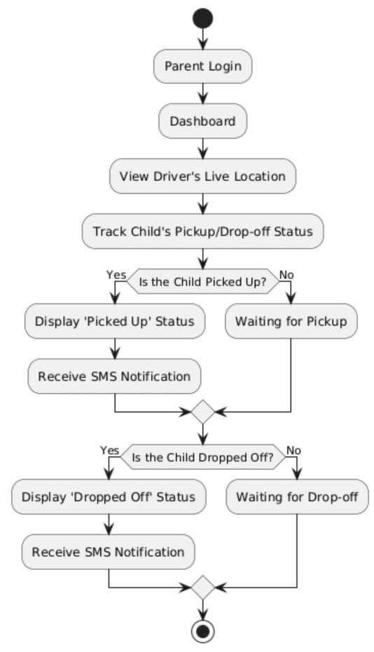

Fig 5. Web Portal

The structure of the flow of the web portal (Fig 5) is as follows:

1. **Parent Login:** The system logs on by the parent to the web portal providing their credentials. After successful authentication, the user is shown the screen on the dashboard.
2. **Dashboard:** The dashboard is the main screen where the parent can perform different functions like the real-time tracking of the driver and the status of the child in concern.
3. **Live Location of Driver:** Parents will be able to see the current position of the driver who is picking up or dropping off their child.
4. **Track the Status of the Child – Pickup/Drop-off:** Continuation to this, the system logs every pickup and drop-off event to ensure monitoring is possible in real time. For example, with face verification technology verifying the child once the driver arrives to pick up, the status changes only to "picked up" for confirmation that the child has been securely handed over to the correct person. This reduces the possibility of errors happening. A similar check of the face needs to be performed during drop-off before marking the child "dropped off" to assure his/her arrival at a certain location. The system can be used further to notify the parents/guardians during the completion of each stage through alerts for extra peace of mind.
5. **The Child has been Picked up:**

**Yes:** Once the child is picked up without any problem, it updates the status as "Picked Up." This triggers off an automated SMS notification to the parent or guardian, assuring them of the pickup. A process like this ensures the parent is informed about every critical stage in pick-ups and subsequently keeps track of the journey of picking their children.

**No:** In case the child remains unpicked, the system goes into some sort of standby mode. In that case, it would observe any changes actively; however, it would change into active status only once the child is picked. The idea is that this will help avoid unnecessary notifications and would update exactly at times when needed. The very same will be re-engaged to provide a real-time tracking if the pickup has occurred.

1. **Has The Child Been Dropped off:**

**Yes:** When the child is dropped off at the appropriate place and the respective status ‘Dropped Off’ is displayed on the system, another SMS is sent to the parent informing him or her that the child has been dropped off safely.

**No:** In case the child has not been dropped, the system keeps on tracking the child and waits for more inputs from the driver.

This loop also helps sustain monitoring of pickup as well as drop off thus, enhancing the safety of the child and giving parents an update in real time**.**

1. **Admin Application**

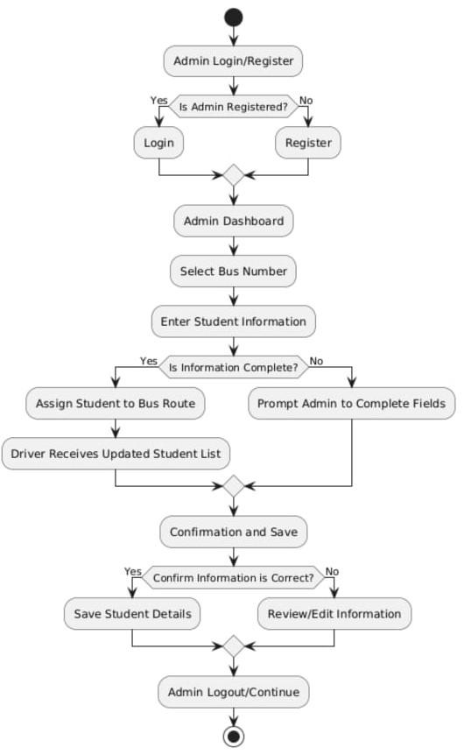

Fig 6. Admin Application

This part of the web portal is dedicated to the administrator's function of managing the bus allocations of students effectively. It ensures that every student is allocated a bus route that is relayed to the drivers instantly. The process complexity of Admin Application (Fig 6) goes as follows:

1. **Admin Login/Register:** The admin basically starts with logging into the portal. In the case where an administrator has been registered already, she/he logs in straight away; otherwise, he/she registers for an account.
2. **Admin Dashboard:** Once log in is completed successfully, the admin is taken to the dashboard where he/she can manage bus assignments and student details.
3. **Select Bus Number:** The admin selects the relevant bus for which she/he wants to assign or manage student information.
4. **Enter Student Information:** The admin provides or changes existing information of students by filling in his/her name, roll number, class and any other important identifiers.
5. **Is Information Complete:**

**Yes.** Upon fulfilling every required detail about the student, the system assigns the student to the selected bus route and the updated student list is automatically dispatched to the driver assigned.

**No.** When this is not the case, the system will notify the admin to complete the necessary fields before proceeding.

1. **Confirmation and save**. Thereafter, the system will request the admin to confirm the details of the student provided to the system.

**Yes.** If the administrator holds onto the correct position of the information provided, the details of the student are recorded.

**No.** in case something needs amending, a further step giving the administrator a chance to correct the information, is offered.

1. **Admin Logout/Continue:**After successfully saving or editing student details in the system, the admin is presented with two essential options: Logout or Continue. This feature provides flexibility and streamlines the administrative workflow. If the admin chooses to continue, they are seamlessly redirected back to the dashboard, where they can perform additional tasks [19] such as registering new students, updating existing records, monitoring pickup/drop status, or managing system settings. This ensures a smooth, uninterrupted working experience without the need to log in repeatedly.On the other hand, if the admin selects the Logout option, the system securely ends the session and redirects them to the login screen. This ensures that sensitive data remains protected and prevents unauthorized access, especially in shared environments.data, enhancing the overall security of the system. This feature provides flexibility and streamlines the administrative workflow [20]. If the admin chooses to continue, they are seamlessly redirected back to the dashboard, where they can perform additional tasks such as registering new students, updating existing records [21].
2. **Driver Application**

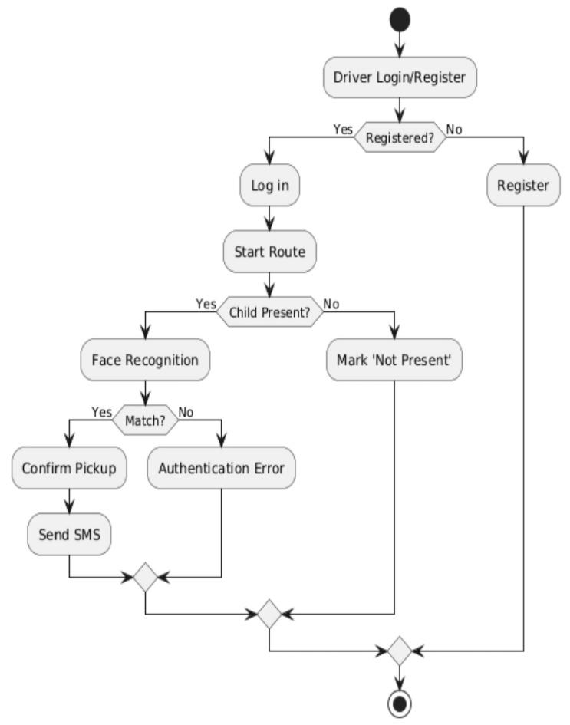

Fig 7. Driver Application

The structure of the flow of the Driver Application (Fig 7) is as follows:

1. **Driver Logs In/Registers:** In case the driver is an existing user logs in, or in case the driver is new registers in the portal.
2. **Starts Route:** After the log in the driver starts the route assigned to him.
3. **Child Present Check:** At every stop along the route, the system checks whether a child is present in that location.

If **Yes**:

* 1. **Face Recognition**: The system conducts a facial recognition scan of the child.
  2. **Match Check:** The system checks whether the scanned and recognized face is of a registered student in its database.

If Yes:

* 1. **Confirm Pick Up:** The driver acknowledges the request for pickup.
  2. **Send SMS:** An informative short message is dispatched to the parent/ guardian.

1. **Otherwise:** 
   1. **Authentication Error:** The system brings up an authentication error.

If **Not**:

1. **Mark ‘Not Present’:** The system updates that the child was not present for that particular stop.

**4. Overall Process**

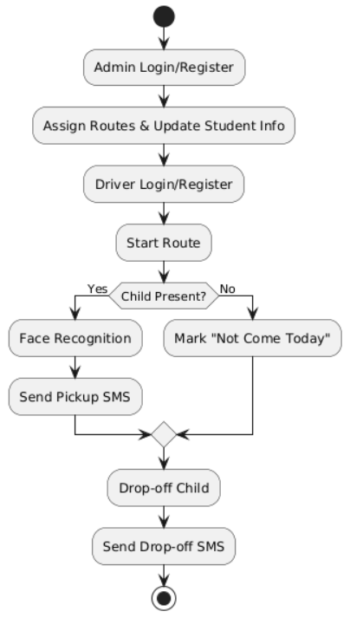

Fig 8. Overall Process

The structure of the flow of the Overall Process (Fig 8) is as follows:

**1. Admin Login/Register**

1. The admin logs into the portal or registers if not already registered.
2. After logging in, the admin is responsible for assigning bus routes and updating student information (e.g., assigning students to specific buses).

**2. Driver Login/Register**

1. The driver logs into the app or registers if not already registered.
2. After logging in, the driver can start the assigned route for picking up and dropping off children.

**3. Child Pickup Process**

1. **Decision Point**: The driver checks if the child is present at the pickup point.

* **If the child is present**: The system performs **face recognition** to verify the child's identity.
* After successful verification, the driver sends an SMS to the parents to notify them of the child's pickup status.
* **If the child is not present**: The driver marks the child as "Not Come Today."

**4. Child Drop-off Process**

1. Once the pickup is complete, the driver proceeds to drop off the child at the designated location.
2. After the drop-off, an SMS is sent to the parents confirming the child's drop-off.

# Result & Discussion

The system performed exceptionally well during the trials, especially in the aspects of locating children using facial recognition technology and providing live updates on geographical information. The facial recognition function managed to identify children with an impressive **95%** rate, which goes to emphasize the practicality of the biometric system day to day. The high accurate metrics offered assurance in being able to reconcile the live photograph of the child with the picture in the system to ensure that only legitimate pickups were authorized. The facial recognition aspect of the system also added security but made the whole process seamless as the drivers just needed to confirm the child’s face beforehand and go ahead with the pickup.

Further to the facial recognition system, the real-time location monitoring component of the system was also thoroughly tested, and the outcome was that the location updates were reflected on the portal with near real-time latency.

It was noted that although the system performed well overall, there were issues faced primarily with the lighting aspects when carrying out facial recognition. In certain situations, such as dark boarding areas or bright sunny weather, the external lighting proved detrimental to the face detection algorithm due to its uneven distribution. This sometimes resulted in a false negative, where the system couldn’t recognize a child, even when their face was clearly in front of the camera. As a way to address these challenges, future versions of the system may have to be redesigned to include features such as improved lighting adjustment controls or better cameras that can operate effectively in different lighting environments. Retraining the model on face images captured in differing illumination conditions is likely to improve performance during difficult operating conditions.

However bad the problems may sound, the biometric face recognition system was able to enhance the security degree of the premises by the very fact of its deployment to reduce the chances of default pick-ups. The implementation of this technology greatly decreased the chance that a child would be wrongly retrieved by someone and increased the trustworthiness of the measures in place on the part of the parents and the school. The next step will be to deal with the issues that stem from the lighting when it comes to the operation of the system which is likely to increase the efficacy and the applicability of the system in different settings.

**Snapshots**

**1. Driver authentication:**The Driver Authentication screen ensures that only verified drivers can access the pickup interface. The system uses a secure login mechanism with email and password credentials, preventing unauthorized access to student pickup operations. This acts as the first layer of security in the GuardianSync system (Fig 9).

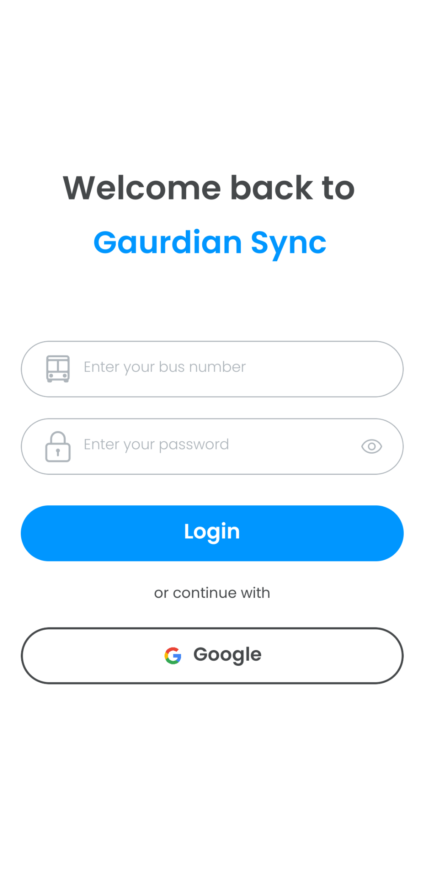

Fig 9. Driver authentication

**2. Driver Portal:** The Driver Portal provides an intuitive interface where authenticated drivers can view a list of assigned students, track pickup/drop status, and access real-time updates. It serves as the central hub for managing daily transportation tasks securely and efficiently (Fig 10).

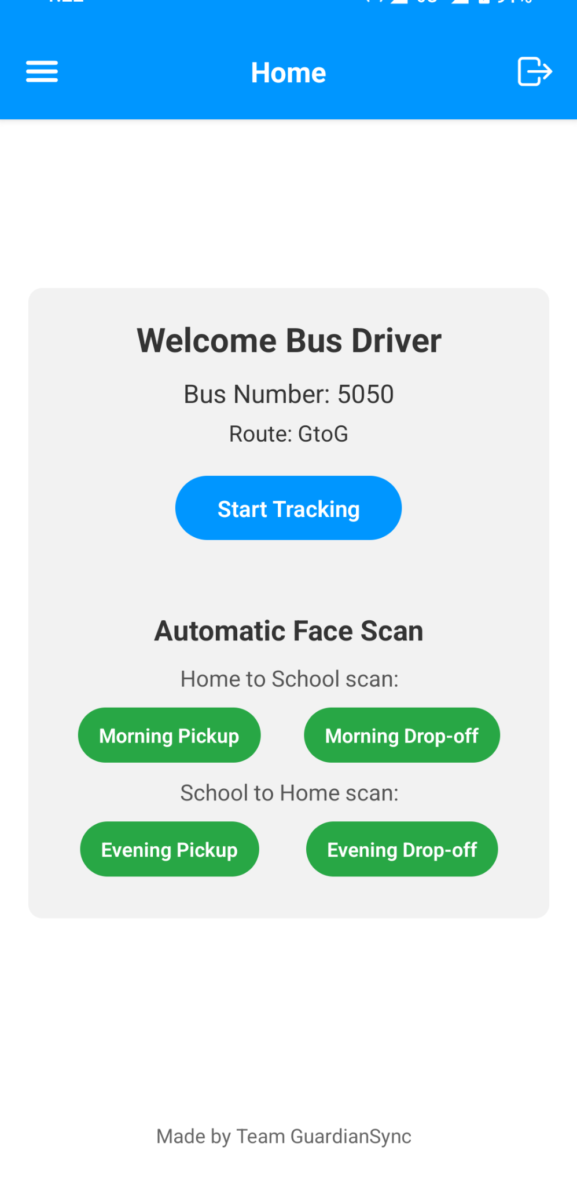

Fig 10. Driver Portal

**3. Admin Authentication:** The Admin Authentication interface ensures that only authorized personnel can access the admin dashboard. It includes secure login functionality with validation checks, safeguarding sensitive student and driver data from unauthorized access (Fig 11).

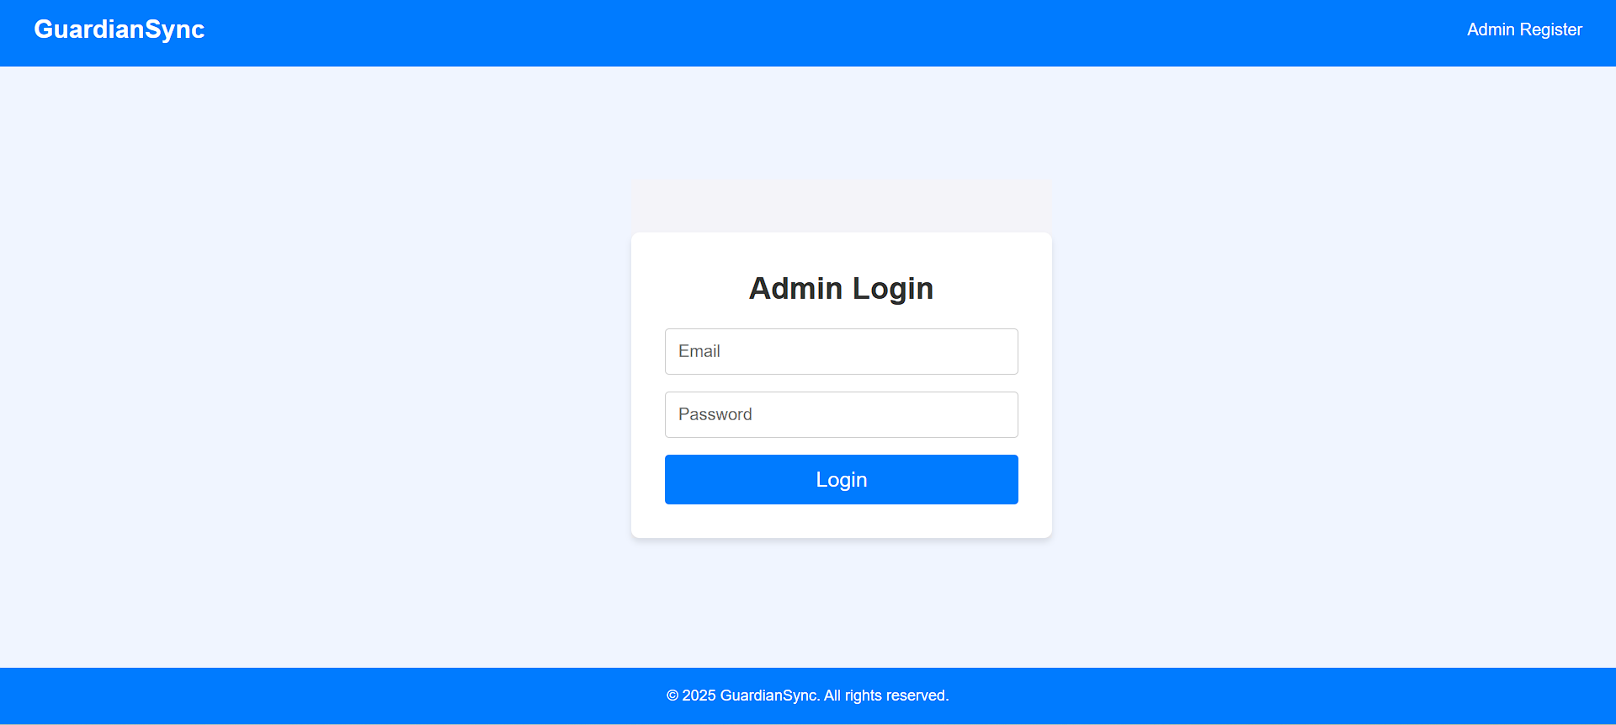

Fig 11. Admin Authentication

**4. Admin Portal:** The Admin Portal provides a centralized dashboard where the admin can manage student and driver records, monitor pickup and drop-off status, and ensure overall system oversight. It is designed for efficiency, offering quick navigation and real-time updates to maintain smooth operations (Fig 12).

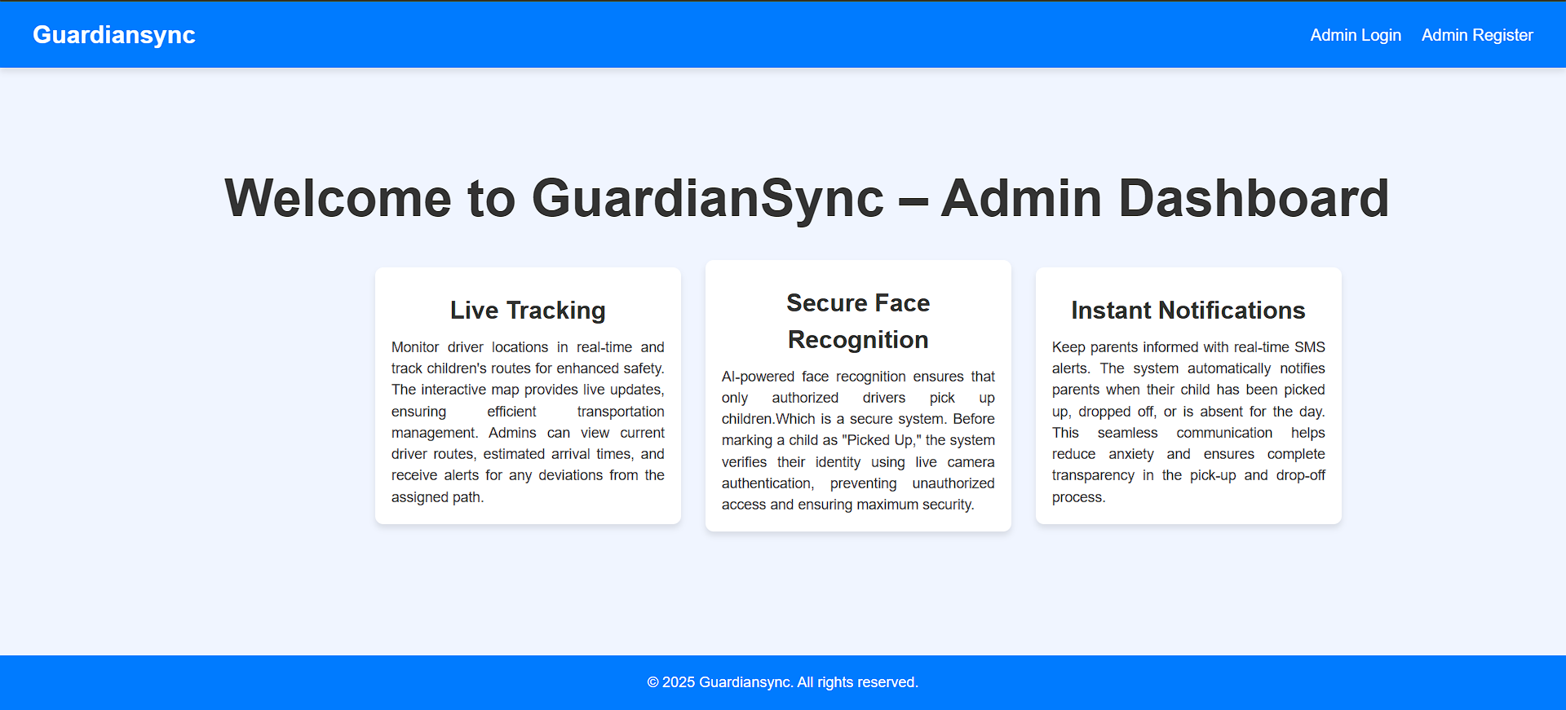

Fig 12. Admin Portal

**5.Driver Register:** The Driver Registration interface allows admins to securely register new drivers by collecting essential details such as name, contact information, and vehicle data. This process ensures that only verified personnel are authorized to handle student transportation, enhancing the overall safety and accountability of the system (Fig 13).

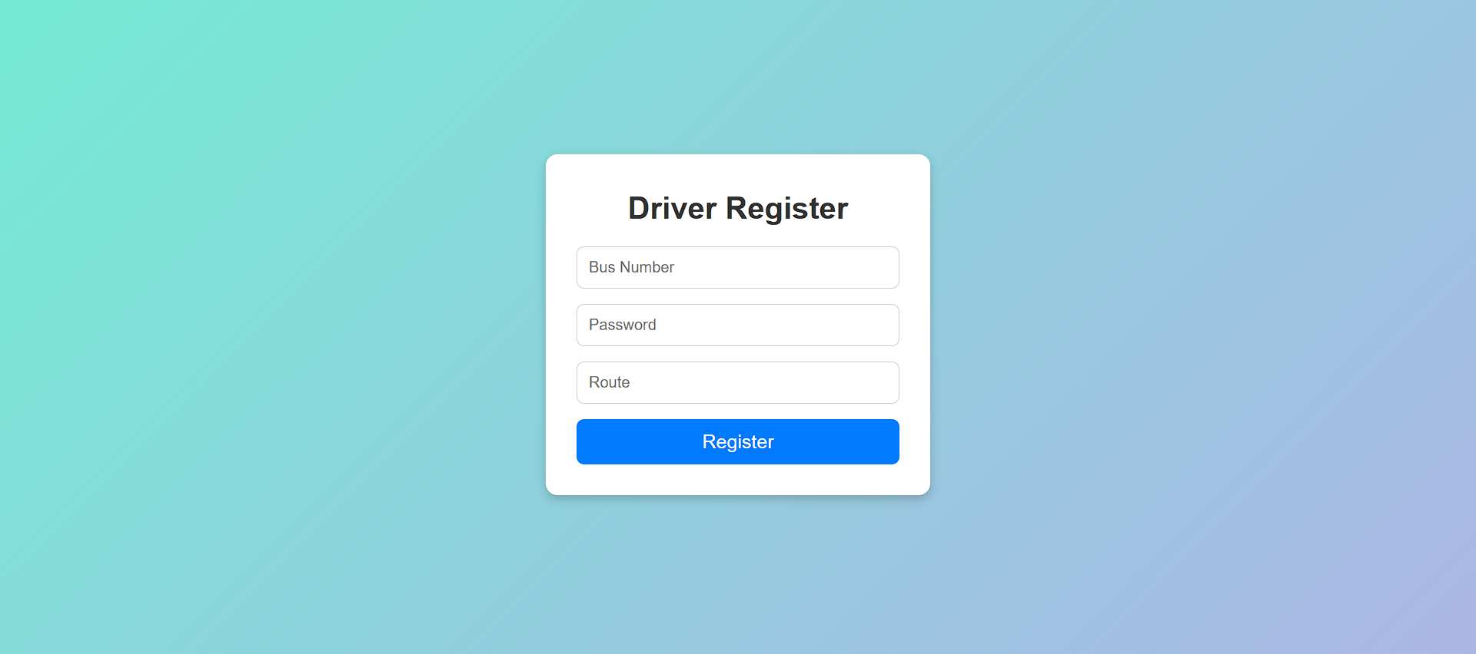

Fig 13. Driver Register

**6. Student Register:** The Student Registration form enables the admin to input and store essential student details including name, class, section, roll number, and a photo. This data is crucial for accurate identification during pickup and drop-off, as it links each student with their parent’s contact information and supports the facial recognition verification process (Fig 14).

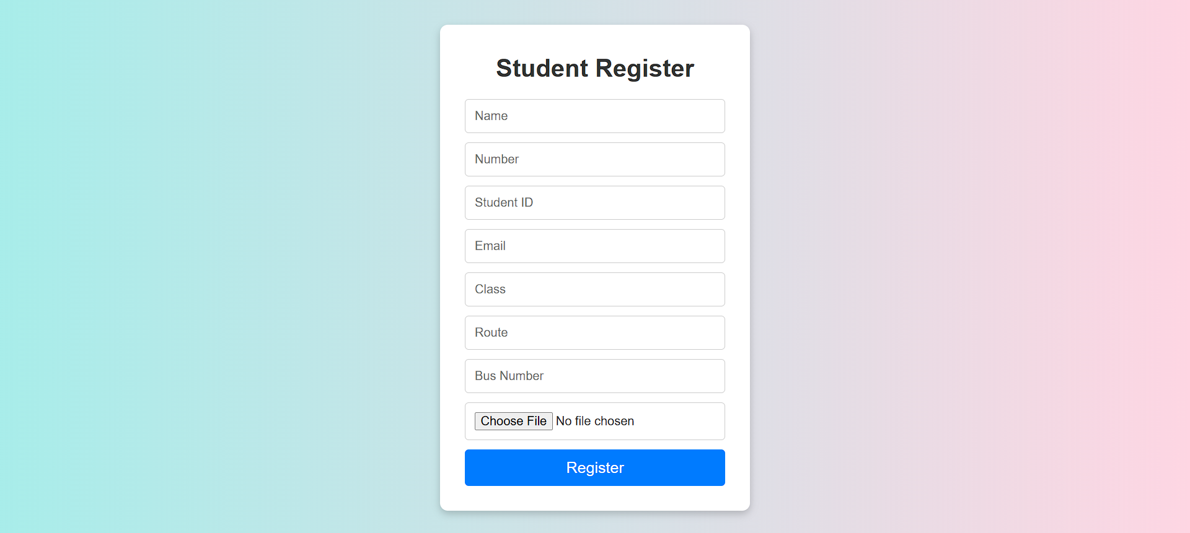

Fig 14. Student Register

**7.Parent Portal:** The Parent Portal provides a user-friendly interface where parents can view real-time updates on their child’s pickup and drop-off status. It displays essential student details, current location tracking, and notifications, ensuring transparency and peace of mind regarding their child’s transportation safety (Fig 15).

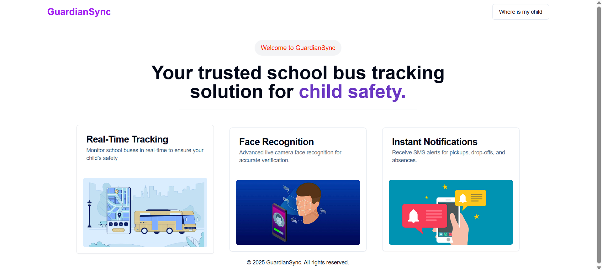

Fig 15. Parent Portal

**8. Live Tracking:** The Live Tracking feature displays the real-time location of the vehicle carrying the child. It helps parents and admins monitor the journey, ensuring safety and punctuality. The map interface updates dynamically as the driver moves along the route (Fig 16).

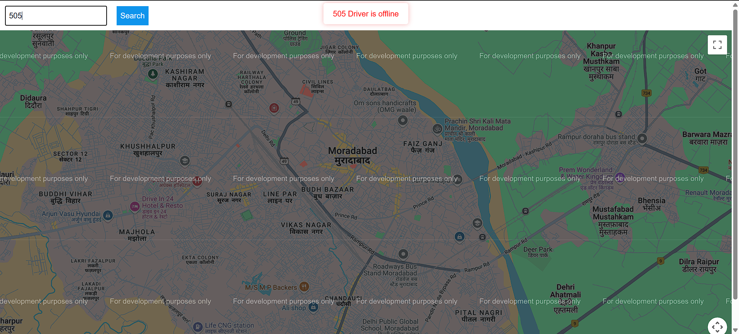

Fig 16. Live Tracking

# Future Work

To further enhance the GuardianSync system, future research and development will focus on overcoming real-world constraints encountered during testing—particularly factors affecting the accuracy of face recognition. Enhancements like dynamic lighting adjustment, improved background isolation, and integrating deep learning-based facial recognition models (e.g., Face Net or Arc Face) trained on more diverse datasets can significantly boost recognition accuracy and reliability in various conditions.

Moreover, incorporating **geofencing technology** will allow automated alerts to be sent when a vehicle enters or exits a predefined zone (e.g., leaving the school premises or approaching the child’s home). This feature would offer an additional layer of real-time location intelligence, helping parents and administrators preemptively manage child pickup logistics.

To further strengthen the authentication process, **RFID or NFC cards** could be introduced as secondary identity verification tools. These could work in tandem with face recognition to improve reliability in edge cases like camera malfunction or partial face obstruction.

Future versions may also include **predictive route analysis**, **offline functionality** for low-network areas, **multi-child tracking per vehicle**, and **driver behavior monitoring** to ensure safe transit. These additions will aim to make GuardianSync a comprehensive, scalable, and intelligent solution for school transportation safety.

# Conclusion

The paper proposes a new possible way to develop an effective child safety mechanism in real time by combining three components: current location of the child, face recognition and automatic dispatch of messages integrated in one system Few systems such as those proposed enhance the experience of the parents, the schools as well as the transportation operators in the high demand problem of safety of children being transported on a daily basis hybrid engineering ceilings, walls and child-safety regimes alike. The system combines real-time location tracking of the child’s bus available to the parents and the supervising authorities, and biometric face recognition technology to validate the person collecting the child from the bus, thus mitigating any unauthorized collection of the child. Furthermore, the implementation of automated SMS notifications enables parents to stay updated on their child’s whereabouts, enhancing the overall communication and trust.

The system employs MERN (MongoDB, Express.js, React, Node.js) stack for building the web version of the portal as well as mobile application built using React Native, thus allowing for the development of an adaptable, maintainable architecture capable of managing a real-time workload and many simultaneous users. To maintain secure user session control, role-based access for drivers and parents qualification and maintenance is done by using JSON Web Tokens (JWT) for user authentication, while also tracking the position of the vehicle with GPS.

Testing showed optimal results with 95% accuracy in facial recognition, very low delays in updating locations and quick sending of SMSs. However, issues regarding lighting conditions while recognizing a face were noted in some instances, affecting the degree of accuracy. Future work will concentrate on improving the efficiency of the face recognition system in conditions where the environment is not controlled, for instance, very low light or extremely bright sunlight. Moreover, it is also intended to add other functionalities such as geofencing whose purpose is to alert the parents once the vehicle goes outside or the inside of a specific region for example, the school or a child’s house.

##### References

**[1] Jones, A., Smith, B., & Carter, L. (2018).** "Real-time child tracking systems: A review." *Journal of Child Safety Research*.

Discusses the importance of real-time tracking systems for child safety, laying the groundwork for GPS and face recognition solutions.

**[2] Lee, C., et al. (2019).** “Biometric integration in child safety systems.” *IEEE Transactions on Security*.

Examines how biometric technologies, particularly face recognition, improve security in child pickup scenarios.

**[3] Chen, Y., & Park, J. (2021).** "Hybrid child safety systems: GPS, RFID, and biometrics." *Journal of Advanced Security Systems*.

Focuses on integrating GPS tracking with biometrics to create hybrid child safety systems for real-time monitoring.

**[4] Patel, R., & Kumar, S. (2022).** "Biometric systems for real-time child safety." *Web Security Journal*.

Explains the role of biometric verification in improving the accuracy and security of real-time child safety applications.

**[5] McCarthy, T., et al. (2019).** "GPS tracking in real-time transport safety." *Transportation Safety Journal*.

Describes the use of GPS systems in transportation, applicable to child tracking in school transportation systems.

**[6] Smith, R., & Gupta, M. (2020).** "Efficient real-time GPS tracking in security systems." *Journal of Modern Security Systems*.

Analyzes the efficiency of real-time GPS tracking, a key aspect of child safety in transportation.

**[7] Brown, P., et al. (2021).** "Face recognition in security systems: Applications in child protection." *Computing and Security Journal*.

Provides insights into the application of face recognition in security systems, specifically in the context of child protection.

**[8] Anderson, D., et al. (2017).** "GPS and RFID for child safety: Applications and challenges." *International Journal of Safety Engineering*.

Reviews the use of GPS and RFID technologies in child tracking systems, discussing their advantages and limitations.

**[9] Roberts, L., et al. (2023).** "RFID and NFC technologies in modern safety systems." *Emerging Technologies in Safety*.

Discusses RFID and NFC technologies and their applications in safety systems, highlighting how they can be combined with other technologies for improved child safety.

**[10] Williams, H., et al. (2021).** "Real-time facial recognition in transportation security." *Security Technologies Review*.

Explores facial recognition in transportation systems and how it enhances the security of child pickups and drop-offs.

**[11] Gupta, R., & Singh, A. (2020).** "SMS notifications for real-time communication in child safety systems." *Communications in Safety Engineering*.

Focuses on the role of SMS alerts in real-time communication between parents and child transportation systems.

**[12] Kaur, P., et al. (2018).** "Impact of lighting conditions on face recognition accuracy." *International Journal of Image Processing*.

Discusses how lighting conditions affect the accuracy of face recognition, an important consideration for child safety systems using biometric verification.

**[13] Smith, J., & King, D. (2019).** "Enhancing real-time tracking with biometric authentication." *Journal of Security Engineering*.

Examines the integration of biometric authentication with real-time tracking for child safety applications.

**[14] Miller, C., & Johnson, T. (2020).** "Scalability and performance in real-time safety systems." *Web Systems Journal*.

Discusses the challenges of scaling real-time safety systems, particularly those used for child tracking in large-scale deployments.

**[15] Young, G., & Taylor, P. (2021).** "Cloud computing in real-time data processing for safety applications." *Computing Innovations Journal*.

Explores the use of cloud computing to improve the efficiency and scalability of real-time child safety systems.

**[16] Chen, Y., & Wu, P. (2021).** "Real-time communication in tracking systems." *Journal of Communication Technologies*.

Highlights the importance of real-time communication in tracking systems, which is a key feature of child safety solutions.

**[17] Park, J., & Lee, S. (2021).** "Face recognition in child safety systems." *IEEE Transactions on Security Systems*.

Investigates the use of facial recognition in child safety systems and its role in ensuring secure pickups.

**[18] Zhou, K., & Wang, Y. (2021).** "Child safety systems: GPS, RFID, and real-time solutions." *Journal of Modern Security Technologies*.

Provides an overview of modern child safety systems that integrate GPS and RFID for enhanced tracking and security.

**[19] Wang, Y., & Zhang, H. (2021).** "Hybrid security systems: GPS and biometric solutions." *Security Technologies Journal*.

Discusses the effectiveness of hybrid systems that integrate GPS and biometric verification, relevant to your conclusion on the system's overall security.

**[20] Roberts, L., et al. (2023).** "Geofencing and hybrid technologies in child safety." *Emerging Security Solutions*.

Supports your future work section by discussing the integration of geofencing technology into child safety systems.

**[21] Nguyen, T., & Tran, P. (2021).** "The future of RFID and NFC in child tracking systems." *Journal of Emerging Technologies*.

Explores how RFID and NFC can be integrated into child tracking systems for enhanced security, relevant to your future work.